EXCEPTION HANDLING IN PYTHON

- Try ..except block
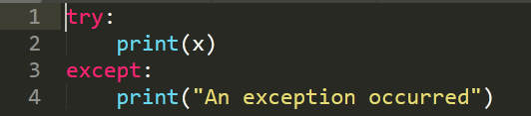
Output:

- ZeroDivisionError Exception
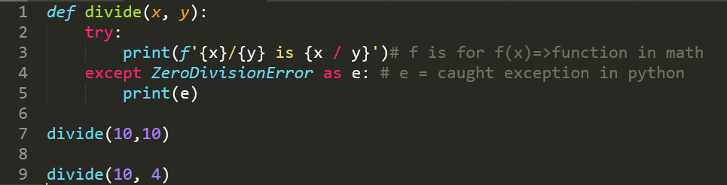
Output:
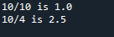

Now, add code as below:
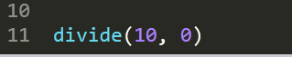
Output:

3.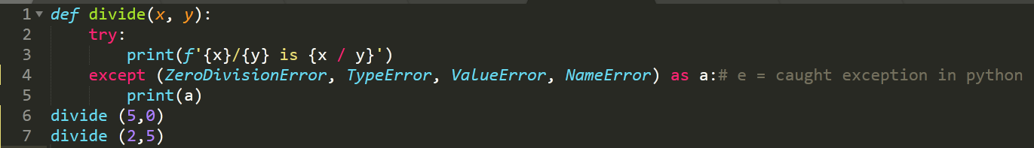

Output:
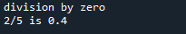

4. NameError Exception
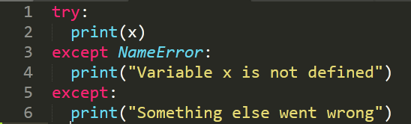
Output:

5. try..except..else
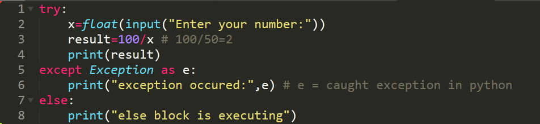
Run the code and insert number 10, observe the output. Then run again and insert number 0.
Output 1:
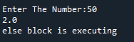

Output 2:

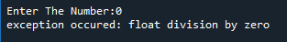

6. Nested Exception
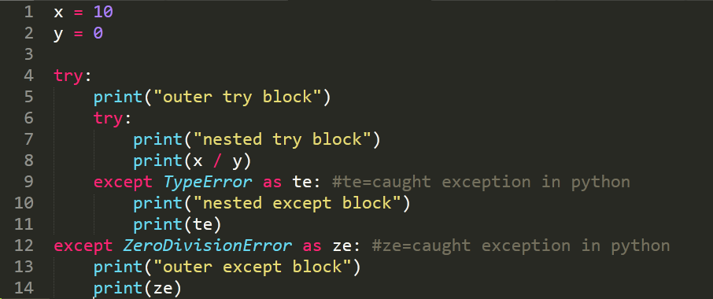
Output:
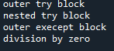

7.
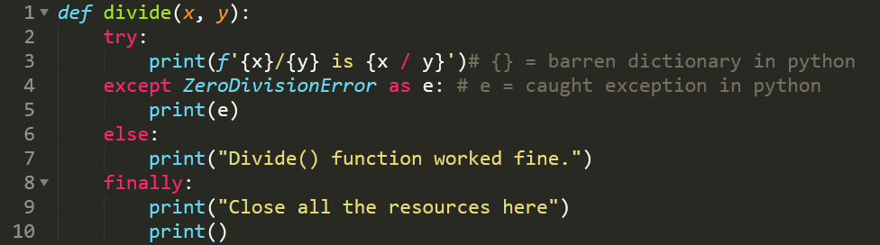
Then continue type the segment code as below:
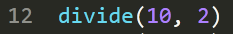
Output 1:

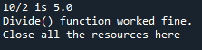

Output 2:

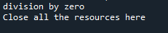

Output 3:
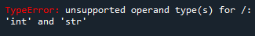

8. 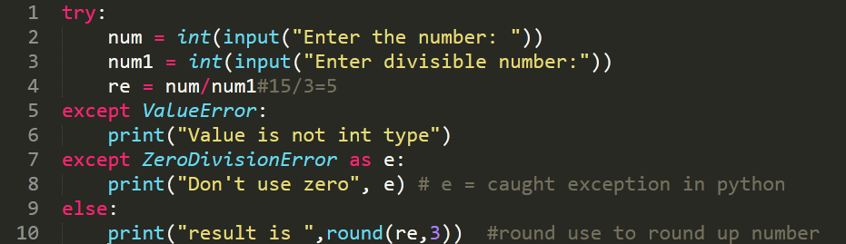
Run the code and insert input as below:
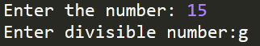

Output 1:

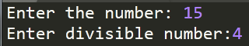
Output 2:

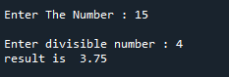

9. Raising Exception
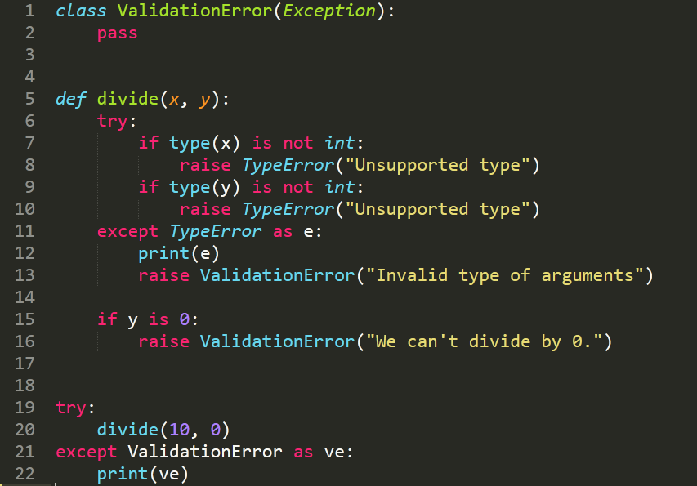
Run and observe the output
Output:

Now change line no 20 as below and run.
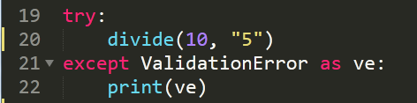
Output:
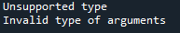

10. Raising Exception
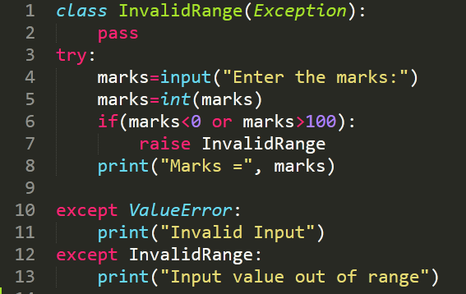
Output:

Output:

